IOT Garbage Monitoring System

This project IOT Garbage Monitoring system is a very innovative system which will help to keep the cities clean. This system monitors the garbage bins and informs about the level of garbage collected in the garbage bins via a web page. For this the system uses ultrasonic sensors placed over the bins to detect the garbage level and compare it with the garbage bins depth. The system makes use of AVR family microcontroller, LCD screen, Wi-Fi modem for sending data and a buzzer. The system is powered by a 12V transformer. The LCD screen is used to display the status of the level of garbage collected in the bins.

Whereas a web page is built to show the status to the user monitoring it. The web page gives a graphical view of the garbage bins and highlights the garbage collected in color in order to show the level of garbage collected. The LCD screen shows the status of the garbage level. The system puts on the buzzer when the level of garbage collected crosses the set limit. Thus this system helps to keep the city clean by informing about the garbage levels of the bins by providing graphical image of the bins via a web page.

Block Diagram:

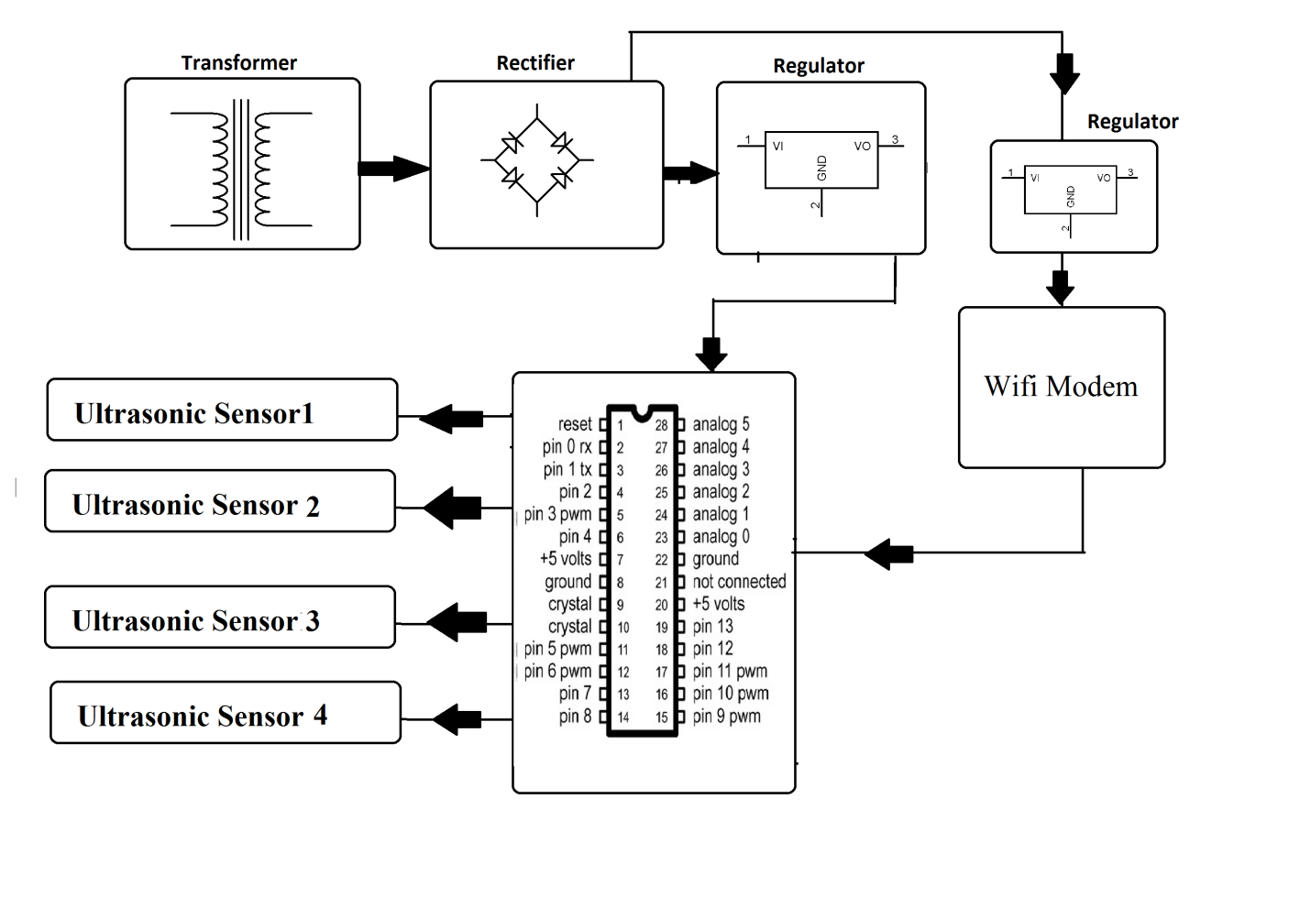

Hardware Specifications
- AVR family microcontroller
- Wi-Fi Modem
- LED’s
- LCD Display
- 12V transformer
- Ultrasonic sensors
- Resistors
- Capacitors
- Diodes

Software Specifications
- Arduino compiler
- IOTGecko
- MC Programming Language: Embedded C

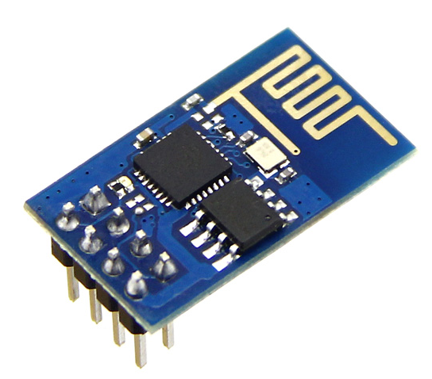
WIFI Modem:
- The ESP8266 Wi-Fi Module is a self contained SOC with integrated TCP/IP protocol stack that can give any microcontroller access to your Wi-Fi network. The ESP8266 is capable of either hosting an application or offloading all Wi-Fi networking functions from another application processor. Each ESP8266 module comes pre-programmed with an AT command set firmware. The ESP8266 module is an extremely cost effective board with a huge, and ever growing, community.
- This module has a powerful enough on-board processing and storage capability that allows it to be integrated with the sensors and other application specific devices through its GPIOs with minimal development up-front and minimal loading during runtime. Its high degree of on-chip integration allows for minimal external circuitry, including the front-end module, is designed to occupy minimal PCB area. The ESP8266 supports APSD for VoIP applications and Bluetooth co-existence interfaces, it contains a self-calibrated RF allowing it to work under all operating conditions, and requires no external RF parts.
- There is an almost limitless fountain of information available for the ESP8266, all of which has been provided by amazing community support. In the Documents section below you will find many resources to aid you in using the ESP8266, even instructions on how to transforming this module into an IOT (Internet of Things) solution!
- Note: The ESP8266 Module is not capable of 5-3V logic shifting and will require an external Logic Level Converter. Please do not power it directly from your 5V dev board.
Features:
- 802.11 b/g/n
- Wi-Fi Direct (P2P), soft-AP
- Integrated TCP/IP protocol stack
- Integrated TR switch, balun, LNA, power amplifier and matching network
- Integrated PLLs, regulators, DCXO and power management units
- +19.5dBm output power in 802.11b mode
- Power down leakage current of <10uA
- 1MB Flash Memory
- Integrated low power 32-bit CPU could be used as application processor
- SDIO 1.1 / 2.0, SPI, UART
- STBC, 1×1 MIMO, 2×1 MIMO
- A-MPDU & A-MSDU aggregation & 0.4ms guard interval
- Wake up and transmit packets in < 2ms
- Standby power consumption of < 1.0mW (DTIM3)
Reference
- http://ieeexplore.ieee.org/xpl/articleDetails.jsp?arnumber=7264372&newsearch=true&queryText=iot%20garbage

